Project Design Phase
Problem – Solution Fit

Date | 16th september 2026
Team ID | SWTID-2026-5883
Project Name | Ai weather wise
Maximum Marks | 2 Marks

Problem – Solution Fit :
The Problem-Solution Fit simply means that you have found a problem with your customer and that the solution you have realized for it actually solves the customer’s problem. It helps entrepreneurs, marketers and corporate innovators identify behavioral patterns and recognize what would work and why
Purpose:
- Solve complex problems in a way that fits the state of your customers.
- Succeed faster and increase your solution adoption by tapping into existing mediums and channels of behavior.
- Sharpen your communication and marketing strategy with the right triggers and messaging.
- Increase touch-points with your company by finding the right problem-behavior fit and building trust by solving frequent annoyances, or urgent or costly problems.
- Understand the existing situation in order to improve it for your target group.

Template:
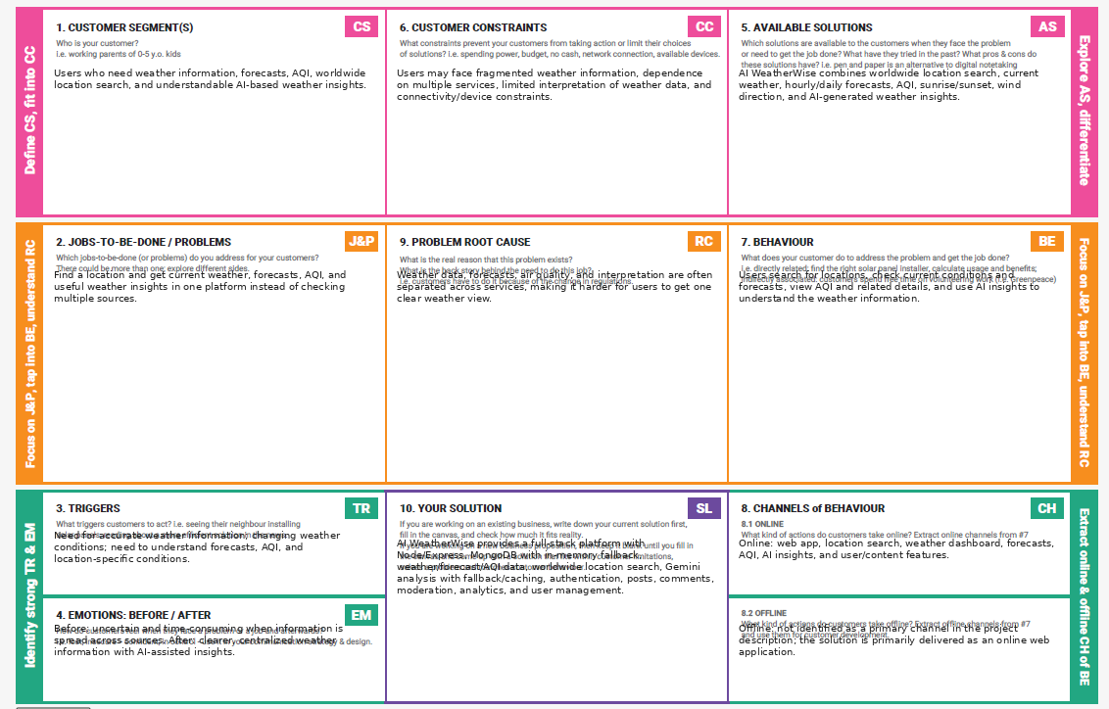
References:
- https://www.ideahackers.network/problem-solution-fit-canvas/
- https://medium.com/@epicantus/problem-solution-fit-canvas-aa3dd59cb4fe

